**ThriveOn King directions: A guide to parking and Foundation headquarters**

**Mailing Address:** 2153 N. Dr. Martin Luther King Jr. Dr., Suite 4000 (4th floor)

**Parking structure and building entrance address:** 320 W. Lloyd St. It is on the corner of W. Lloyd St and Vel R. Phillips Ave.

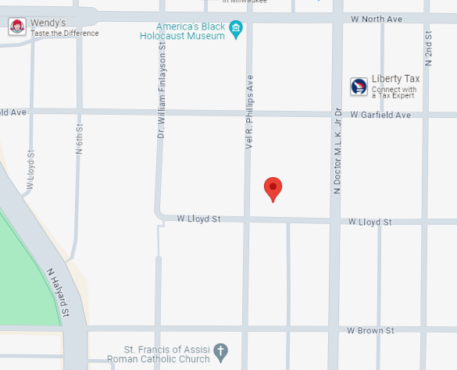



Building Entrance

Parking

|  |  |
| --- | --- |
| **Directions** | **Visual cues** |
| The parking structure entrance and exit are located on the corner of W. Lloyd St. and Vel R. Phillips Ave. |  |
| Parking structure access is not limited. The arm to the entrance will be raised to ensure a smooth entry, but if down, it will raise as you approach | A parking garage with a barrier |
| Once parked, walk to the northeast corner to take the stairs down to the ground level.  The parking structure elevators are not operational at this time. | A building with glass doors |
| The building entrance is directly across from the parking structure. Cross the vestibule and enter through the doors. |  |
| To take the elevator, turn left toward the reception desk. |  |
| Elevators are to the right of the reception desk and staff members will be present to take you to the fourth floor. |  |
| The elevator opens to the Foundation’s reception area on the fourth floor. Once there, staff members will be present to show you to the Board room and bathrooms or answer any questions. |  |
| **Staircase option** |  |
| To take the stairs to the fourth floor, take a right past the mailboxes. |  |
| Look for staircase C. |  |
| Take the staircase to the fourth floor. |  |
| Bear in mind, the stairwell makes a stop at the mezzanine level so look for the fourth floor sign.  Staff members will be available to take you upstairs and swipe you in. |  |